# **Machine learning YouTube**

## **1.1 AI vs ML v DL**

Machine learning is a subset of Artificial Intelligence. Deep learning is a subset of Machine learning.

**Artificial Intelligence:** Artificial Intelligence is a branch of computer science that is concerned with building smart and intelligent machines. Example of non-intelligence machines: bike, watch as they can not think by their own, they just do specific work that are assigned to them. Intelligent Machine-like autonomous car or driver less car like tesla that do not need any input from drivers and can run the car depending on the road situation and map. Similarly, google assistance also an intelligent machine that uses AI as while we talk with this assistance, we do not feel like we are talking to any machine rather than it works like human.

**Machine learning:** Machine learning is a technique to implement AI that can learn form the data by themselves without being explicitly programmed. So, machine learning is all about the data. Let’s assume we want to build a machine so that it can predict Iron man and captain America by seeing the given picture. For this to implement we need to feed different type of iron man and captain America’s picture and machine learning algorithm will find the pattern between images by their own. When we give a new image, it will correctly predict the actual figure of iron man or captain America. So, we need to feed different data to the machine learning algorithm so that they can predict the pattern between them.

**Deep Learning:** Deep learning is a subset of machine learning that uses Artificial Neural Networks to learn from the data.

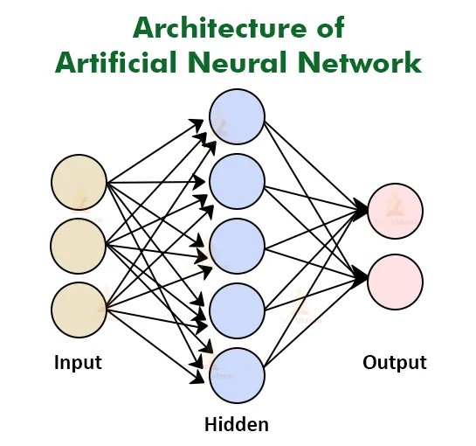

These artificial neural networks modeled from our human brain from the neurons present in our human brain. There are numerous neurons in our brain which are interconnected with each other. Each neuron processes the information and sends the output other neurons, by using this concept artificial neural networks are designed. They are nothing but mathematical model that are connected with each other like neurons like our brain.

## **1.2 Supervised Learning vs Unsupervised Learning vs Reinforcement learning**

There are three main types of machine learning

1. Supervised Learning
2. Unsupervised Learning
3. Reinforcement Learning

**Supervised Learning:** In supervised learning, the machine learning algorithm learns from Labelled data. Let’s assume we want to feed ML algorithm some fruit’s image and will tell them which image is which like mango, apple etc. This is called labelled data and these labelled data set to the ML model. ML model or algorithm will try to find patterns between these images. When it learns from the data and seeing some unknown images it will be able to identify the current data. This is why this type is called supervised learning.

**Unsupervised Learning:** In unsupervised learning ML algorithm learns from unlabeled data. Here data will be given without any label, for example we give some images of mango and apple without telling which one is mango and which one is apple. ML algorithm will try to find the pattern between the images and try to group all the images depending on the pattern. When we give some unknow image it will tell the group name which the image is belong. This is called unsupervised learning.

**Reinforcement Learning:** Reinforcement learning is an area of machine learning concerned with how intelligent agents take actions in an environment to maximize its rewards. In this learning there are four parts, which are

1. Environment
2. Agent
3. Action
4. Reward

There will be an environment where we need to build an agent which will acts in that environment. That agent will take action in that environment and for all action it will gain some rewards. Example, we want to built a software or computer program that can play chess like a human. Here, chess board is an environment, computer is an agent. Every move in that chess game will represent as an action and for each step it gets reward, where as the ultimate reward is wining the chess game. For every right move computer gets positive reward and for wrong move it gets negative reward. Several applications like autonomous car/drone, AI powered video games are based on reinforcement learning.

## **Supervised Learning, types of supervised learning**

There are two main types of supervised learning, such as

1. Classification
2. Regression

**Classification:** Classification is about predicting a class or discrete values such as, male or female, dog or cat etc. There won’t be any continuous value or numbers, it will predict only classes. In this supervised learning we will feed some pictures with label of dog and cat, and ML models will classify dog or cat y analyzing the given labeled pictures.

**Regression:** Regression is about predicting a quantity or continuous values, such as age, price etc. For instance, we need to predict a person’s salary depending or his experience, where salary will be a continuous number.

Let’s say we need to predict the rainfall in centimeter value for a given temperatures/pressures ad other values. In this case we will train the ML model with data like how much rain falls depending on the temperature, pressure and other scenario, and while we will give different temperature it will give expect rainfall in centimeter.

**Algorithms of classification and regression**

**Classification**

1. Decision Tree classification
2. Random forest classification
3. K-nearest neighbor

**Regression**

1. Logistic regression
2. Polynomial regression
3. Support vector machines